|  |
| --- |
|  |
| Cloncurry State School P-12 |

2024-2027

**Student Code of Conduct**

***Equity and Excellence: realising the potential of every student***

***Equity and Excellence outlines the government's vision for a progressive, high-performing education system. Equity and Excellence provides clarity for schools about priorities and expectations, with differentiated support targeted to each school's context and needs.***

*Queensland Department of Education*

|  |
| --- |
| Contents |
|  |

|  |  |
| --- | --- |
| Purpose | 3 |
| Contact Information | 3 |
| Endorsement | 3 |
| Principals Foreword | 4 |
| P&C Statement of Support | 5 |
| School Captains Statement | 6 |
| Data Overview  School Opinion Survey  School Disciplinary Absences (SDA) | 7  7  8 |
| Consultation | 9 |
| Learning and Behaviour Statement  Multi-Tiered System of Support  Student Wellbeing  Student Success Team | 10  10  12  13 |
| Whole School Approach to Discipline  Consideration of Individual Circumstances  Differentiated and Explicit Teaching  School Wide Expectations Teaching Matrix  Focused Teaching  Intensive Teaching | 16  16  17  18  19  19 |
| Legislative Delegations | 20 |
| Disciplinary Consequences | 21 |
| Minor/Major Behaviour Definitions | 23 |
| School Disciplinary Absences | 29 |
| School Policies | 30 |
| Temporary Removal of Student Property | 31 |
| Use of Mobile Phones and Other Devices by Students | 34 |
| Preventing and Responding to Bullying | 36 |
| Appropriate Use of Social Media | 42 |
| Restrictive Practices | 44 |
| Critical Incidents | 45 |
| Related Procedures and Guidelines | 46 |
| Conclusion | 47 |

|  |
| --- |
| Purpose |
|  |

Cloncurry State School P-12 is committed to providing a safe, respectful and disciplined learning environment for all students, staff, parents and visitors. Where students have opportunities to engage in quality learning experiences and acquire values supportive of their lifelong wellbeing.

The Cloncurry State School P-12 Student Code of Conduct sets out the responsibilities and processes we use in our school to promote a productive, effective whole school approach to discipline.

Its purpose is to facilitate high standards of behaviour from all in the school community, ensuring learning and teaching in our school is prioritised, where all students are able to experience success and staff enjoy a safe workplace.

|  |
| --- |
| Contact Information |
|  |

|  |  |
| --- | --- |
| Postal address: | PO Box 337, Cloncurry, QLD, 4824 |
| Phone: | 07 47428333 |
| Email: | the.principal@cloncurryss.eq.edu.au |
| School website address: | https://cloncurryss.eq.edu.au |
| Contact Person: | Victoria Menkins (Principal) |

|  |
| --- |
| Endorsement |
|  |

|  |  |
| --- | --- |
| Principal Name: | Victoria Menkins |
| Principal Signature: |  |
| Date: | 18-10-2023 |
|  |  |
| P/C President and-or School Council Chair Name: | Judith Robertson |
| P/C President and-or School Council Chair Signature: |  |
| Date: | 18-10-2023 |

|  |
| --- |
| Principal’s Foreword |
|  |

Cloncurry State School P-12 has a very proud co-educational history spanning 13 years of education from Prep to Year 12 and has a long tradition of providing high quality education to students from across the remote north west of Queensland. We believe strong, positive relationships between all members of our school are the foundation to supporting the success of all students. We welcome families from all over Australia and overseas. We are deliberate with intention to promote a sense of pride and belonging in our community, across all cultural backgrounds. We promote the local indigenous culture through co-planning and teaching units of work with embedded Aboriginal and Torres Strait Islander perspectives. Taking students on local ‘bush walks’ and the school’s NAIDOC Celebrations are a highlight of the calendar year.

Cloncurry State School P-12 has three core values; Courtesy, Truth and Knowledge. These values have been used in the development of this Student Code of Conduct, with the aim of helping shape and build the skills of all our students to be confident, self-disciplined and kind young people. Our school community has identified the following school rules to teach and promote our high standards of responsible behaviour:

* Be a learner;
* Be safe;
* Be responsible;
* Be respectful.

Our school rules have been agreed upon and endorsed by all staff and our school P&C. Our school staff believe that communication and positive connections with other people are the most valuable skills our communities need now and in the future.

Cloncurry State School P-12 staff take an educative approach to discipline, that behaviour can be taught and that mistakes are opportunities for everyone to learn. Our Student Code of Conduct provides an overview of the school’s local policies on use of mobile phones and other technology, removal of students property and the approach to preventing and addressing incidents of bullying. It also details the steps school staff take to educate students about these policies and how students are explicitly taught the expected behaviours. Finally, it details the consequences that may apply when students breach the expected standards of behaviour, including the use of suspension or exclusion.

The Student Code of Conduct provides a clear explanation of what we expect from students and how we will support them to meet these expectations.

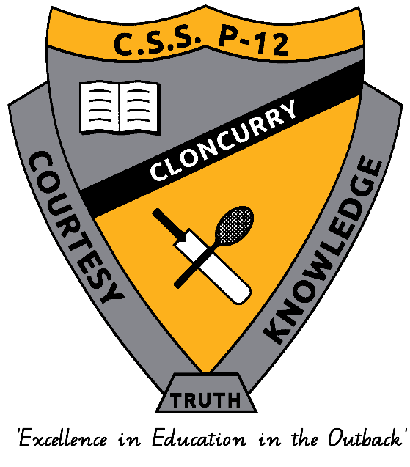

|  |
| --- |
| P&C Statement of Support |
|  |

As president of the Cloncurry State School P-12 P&C Committee, I support the revised Student Code of Conduct. On behalf of the P&C Committee we encourage all parents to familiarise themselves with Cloncurry State School P-12’s Student Code of Conduct, and to take time to talk with their children about the expectations and discuss any support they may need. In particular, we want to emphasize the systems in place to help students affected by bullying.

Bullying is a community-wide issue in which we all have a role to play in combating; however, it can have particularly devastating impacts on our young people. It is important that every parent and child of Cloncurry State School P-12 knows what to do if subjected to bullying, regardless of where it occurs. This includes cyberbullying, through the misuse of social media or text messaging. It is important that parents and children know that the school provides support and advice to help address problems of bullying. The flowchart on page 38 provides an excellent starting point to understand how to approach the school about these types of problems.

Any parents who wish to discuss the Cloncurry State School P-12 Student Code of Conduct and the role of families in supporting the behavioral expectations of students are welcome to join the P&C Association. It is with your support we can work collaboratively with school staff to ensure all students are safe and appropriately supported to meet their individual social and learning needs.

Regards,

Judith Robertson

2023 P&C President

|  |
| --- |
| Data Overview |
|  |

This section is used to report on key measures related to student discipline, safety and wellbeing using existing data sets available to all schools. This provides an open and transparent reporting mechanism for the school community on the perceptions of students, parents and staff about the school climate, attendance and school disciplinary absences.

The Parent, Students and Staff Satisfaction data in the tables below is drawn from the School Opinion Survey. The School Opinion Survey is an annual collection designed to obtain the views of parents/caregivers, students and school staff from each school on what they do well and how they can improve.

Opinions on the school, student learning and student wellbeing are sought from a parent/caregiver in all families and a sample of students from each state school.

Opinions on the school as a workplace are sought from all school staff and principals. There are additional questions for teaching staff on their confidence to teach and improve student outcomes. Principals are also asked about their confidence to lead the school and improve student outcomes.

There are four difference confidential surveys for

* Parents
* Students
* Staff
* Principals

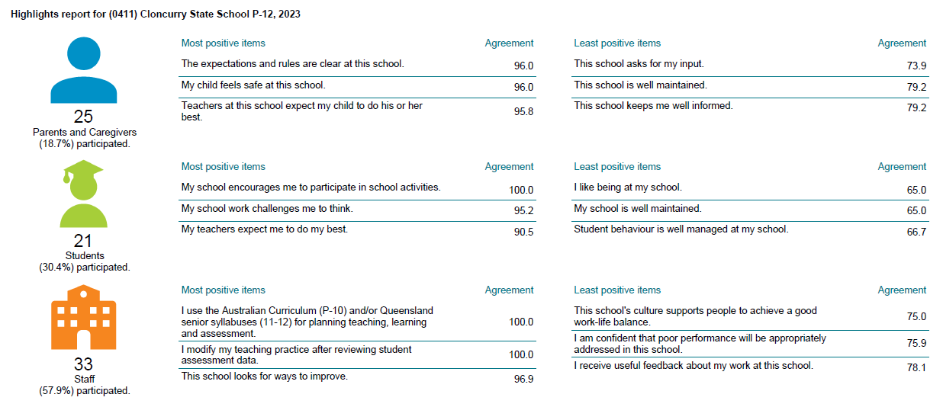

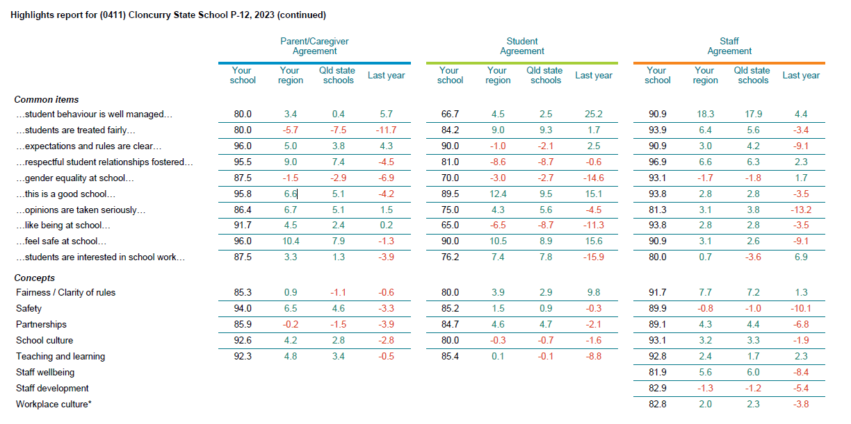

**School Disciplinary Absences (SDA)**

Principals use a range of disciplinary consequences to address inappropriate behaviour. Suspensions, exclusions and cancellations of enrolment are only used as a last resort option for addressing serious behaviour issues. Principals balance individual circumstances and the actions of the students with the needs and rights of the school community members.

All state schools are required to report School Disciplinary Absences (SDA) for the school year in their school annual report. There are four main categories of SDA: short suspension, long suspension, exclusion and charge-related suspension.

The following data shows the count of incidents for students recommended for each type of school disciplinary absence reported at the school.

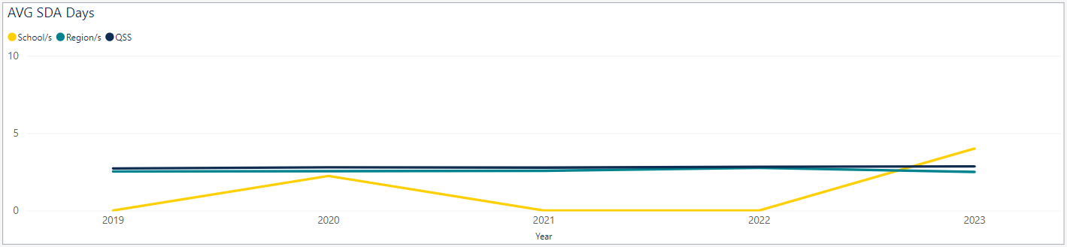**SDA Data: Prep – Year 2**

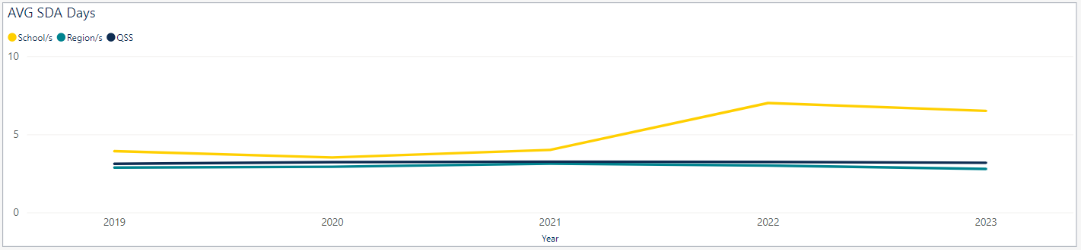**SDA Data: Year 3 – Year 6**

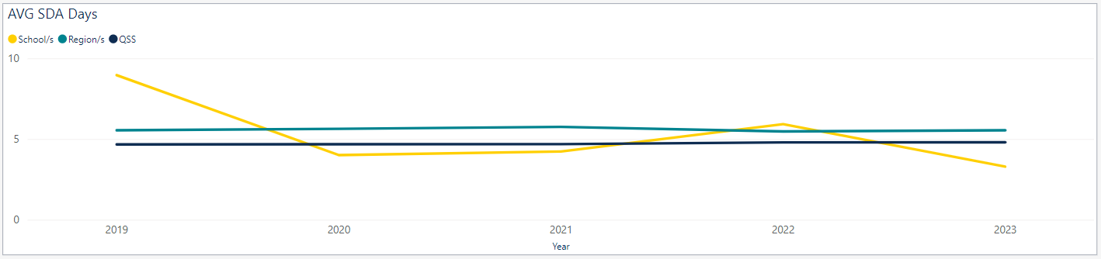**SDA Data: Year 7 – Year 9**

|  |
| --- |
| Consultation |
|  |

A draft Student Code of Conduct was prepared and distributed for comment to all members of the Cloncurry State School P-12 community. Feedback was enacted and a final version of the document was provided to the P&C for endorsement.

A communication strategy has been developed to support the implementation of the Cloncurry State School P-12 Student Code of Conduct, including promotion through the school website, newsletter and Facebook page. Any families who require assistance to access a copy of the Cloncurry State School P-12 Student Code of Conduct are encouraged to contact the Principal.

**Review Statement**

The Cloncurry State School P-12 Student Code of Conduct will undergo annual minor updates to reflect changing circumstances, data and staff. A fulsome review is conducted every four years in line with the scheduled review process for the school.

|  |
| --- |
| Learning and Behaviour Statement |
|  |

Everyone brings their own sets of personal beliefs to a school community. These beliefs influence their decisions, behaviour and social practices. It is reasonable to expect that not everyone will share the same sets of beliefs and this contributes to a richly diverse social environment in each school. It can also contribute to differences in expectations and force us to reflect on our own understanding of what we consider acceptable and unacceptable. We encourage any student or parent to make an appointment with the principal to discuss the model of behaviour support and discipline used at this school.

Multi-Tiered Systems of Support

Cloncurry State School P-12 uses multi-tiered systems of support as the foundation for our integrated approach to learning and behaviour. All areas of Cloncurry State School P-12 are learning and teaching environments. We consider behaviour support to be an opportunity for valuable social learning as well as a means of maximising the success of academic education programs. Multi-tiered systems of support is a preventative, differentiated model grounding in practical strategies, targeted planning and data-informed decision-making. Based on a problem-solving model, in multi-tiered systems of support school staff match increasingly intensive interventions to the identified needs of individual students.

|  |  |
| --- | --- |
| **Tier** | **Prevention Description** |
| **1** | All students (100%) in the school receive support for their academic and behavioural development. Focus is on the whole-school implementation of both the Australian Curriculum and Positive Behaviour for Learning (PBL) expectations. This involves:   * teaching behaviours in the setting they will be used; * being consistent when addressing challenging behaviour, while taking developmental norms and behavioural function into account; * providing refresher lessons and targeted recognition throughout the school year so skills are ready and likely to be used when students need them; * asking students and their families for their perspectives on school climate, instruction, reinforcement and discipline so improvements in Tier 1 may be made.   **Reinforcing expected school behaviour**  At Cloncurry State School P-12, communication of our key messages about behaviour is supported through reinforcement, which provides students with feedback for engaging in expected school behaviour. Reinforcement is designed to increase the quantity and quality of positive interactions between students and staff. All staff members are trained to give consistent and appropriate acknowledgement and rewards.  Staff members acknowledge students explicitly as they observe them following school rules in both the classroom and non-classroom areas. This occurs continuously throughout the day. In order to create a positive, productive and safe environment for teaching and learning, we use a number of strategies both on the individual classroom level and whole school level.  **Redirecting low-level and infrequent problem behaviour**  When a student exhibits low-level and infrequent problem behaviour, the first response of school staff members is to remind the student of expected school behaviour, then ask the student to amend their behaviour so that it aligns with the school’s expectations/rules.  Our preferred way of re-directing problem behaviour is to ask them to think of how they can be a better learner, might be able to act more safely, more respectfully or more responsibly. This encourages students to reflect on their own behaviour, evaluate it against expected school behaviour and plan how their behaviour could be modified so as to align with the expectations of our school community. |
| **2** | Targeted instruction and supports for **some students** (10-15%) are more intense than Tier 1 supports, providing more time and specialisation in services from a range or school-based staff to enable students to meet the required academic and behavioural standards.  Tier 2 supports build on the lessons provided at Tier 1, and may prevent the need for more intensive interventions. Tier 2 supports are provided to small groups of students with similar needs, offering more time and/or detailed instruction on the Australian Curriculum or particular aspects of Positive Behaviour for Learning expectations. The types of interventions offered at this level will vary according to the needs of each school’s student body, but all have certain things in common:   * there is a clear connection between the skills taught in the interventions and the school-wide expectations; * interventions require little time of classroom teachers and are easy to sustain; * variations within each intervention are limited; * interventions have a good chance of working (e.g. they are evidence based interventions that are matched to the student’s need).   If the school data indicates that more than 10-15% of students require targeted services, then a review of Tier 1 is needed to address the basic implementation and quality of instruction. |
| **3** | Individualised services for **few students** (2-5%) who require the most intensive support a school can provide. These are usually delivered in very small groups or on an individual basis.  Tier 3 supports continue to build on the lessons and supports provided at Tiers 1 and 2, becoming more individualised and more intensive until teams can identify what is needed for a student be be successful. Tier 3 supports are based on the underlying reasons for a student’s behaviour (their Functional Behaviour Assessment) and should include strategies to:   * PREVENT problem behaviour; * TEACH the student an acceptable replacement behaviour; * REINFORCE the student’s use of the replacement behaviour; * MINIMISE the payoff for problem behaviour.   Tier 3 supports exist along a continuum. Many students can benefit from a simple (or brief) Functional Behaviour Analysis (FBA) that identifies unique strategies to help the student achieve success. A smaller percentage of students may require a more comprehensive FBA that includes a more thorough process for data collection, teaming and problem-solving. A much smaller percentage of students may need an intensive FBA and wraparound plan that includes personnel from outside agencies and rigorous problem solving procedures.  If the school data indicates that more than 2-5% of the student population requires individualised services, a review of Tier 1 and Tier 2 supports and organisation is recommended. |

Student Wellbeing

Cloncurry State School P-12 offers a range of programs and services to support the wellbeing of students in our school. We encourage parents and students to speak with their class teacher or make an appointment to meet with the Guidance Officer if they would like individual advice about accessing particular services.

Learning and wellbeing are inextricably linked – students learn best when their wellbeing is optimised, and they develop a strong sense of wellbeing when they experience success in learning. The Student Learning and Wellbeing Framework supports state schools with creating positive school cultures and embedding student wellbeing in all aspects of school life through connecting the learning environment, curriculum and pedagogy, policies, procedures and partnerships for learning and life.

**Curriculum and pedagogy**

Schools build the foundations for wellbeing and lifelong learning through curriculum by embedding personal and social capabilities (self-awareness, self-management, social awareness and social management) in the implementation of the P-12 Framework.

At Cloncurry State School P-12 we provide age-appropriate drug and alcohol education that reinforces public health and safety messages; HIV, Hepatitis C and sexually transmissible infections education as part of a broader sexuality and relationships education program; and ensure CPR for Life training is provided to all Year 10 and 12 students. Students all participate in Respectful Relationships education as per the P-12 Framework requirements.

**Policy and expectations**

Within a school community there are specific health and wellbeing issues that will need to be addressed for the whole school, specific students, or in certain circumstances.

*Drug education and intervention*

Cloncurry State School P-12 implements drug intervention measures for students involved in drug-related incidents at school, during school activities or while in school uniform. This is managed to protect the health and safety of the student/s involved, other students, school staff and the wider community.

*Specialised health needs*

Cloncurry State School P-12 works closely with parents to ensure students with specialised health needs, including those requiring specialised heath procedures, have access to a reasonable standard of support for their health needs whilst attending school or school-based activities.

This means that appropriate health plans are developed and followed for students with specialised health needs, that staff are aware of the student’s medical condition and that an appropriate number of staff have been trained to support the student’s health condition.

*Medications*

Cloncurry State School P-12 requires parent consent and medical authorisation to administer any medication (including over the counter medications) to students. For students requiring medication to be administered during school hours, the school can provide further information and relevant forms.

For students with a long-term health condition requiring medication, parents need to provide the school with a *Request to administer medication at school* form signed by the prescribing health practitioner.

Cloncurry State School P-12 maintains a minimum of one adrenaline auto-injector and asthma reliever/puffer, stored in the school’s first aid kit to provide emergency first aid-medication if required.

*Mental Health*

Cloncurry State School P-12 implements early intervention measures and treatments for students where there is a reasonable belief that a student has, or is at risk of developing, a mental health difficulty. Once a student has been identified, the Guidance Officer works with the student, caregivers and staff to make appropriate adjustments and referrals, which are documented in a student’s Personalised Learning Plan.

Suicide prevention

Cloncurry State School P-12 staff who suspect that a student is at risk of suicide are asked to report their concerns immediately to the Guidance Officer and Principal. The Guidance Officer will then meet with the student to obtain an understanding of suicide risk and work with the student, their caregivers and relevant staff and/or external agencies, to create a safety plan.

When dealing with a mental health crisis, schools call 000 when there is an imminent threat to the safety of a student and/or where necessary to provide first aid. In all other situations, Cloncurry State School P-12 staff follow suicide intervention and prevention advice by ensuring:

* The student is not left alone
* Their safety and the safety of other students and staff is maintained
* Students receive appropriate support immediately
* Parents or caregivers are advised
* All actions are documented and reported.

Sometimes students use comments about suicide or self-harm to express a desire for a situation or feeling to go away and do not have suicidal intent. In these situations, the above process will still be followed and the student will be given additional instruction and reminders to use language that better reflects what they meant to express.

Suicide postvention

In the case of a suicide of a student that has not occurred on school grounds, Cloncurry State School P-12 immediately enacts their postvention response plan. Where a suicide has occurred on the school grounds, or at a school event, staff follow emergency procedures prior to enacting the postvention response.

In all instances, as part of the postvention response, the school will communicate with the family of the student, as soon as possible, to ensure that the school’s actions and statements about the young person are sensitive to the family’s wishes and cultural protocols. The response also ensures immediate wellbeing support is available to students and staff who may be affected.

Student Success Team

Cloncurry State School P-12 is proud to have a comprehensive Student Success Team in place to help the social, emotional and physical wellbeing of every student. In addition to the assistance provided by class teachers, we have a team of professionals whose dedicated roles are to help ensure our school is an inclusive, nurturing environment.

Students can approach any trusted school staff member at Cloncurry State School P-12 to seek assistance or advice. If they are unable to assist, they will provide guidance and help ensure the student is connected to the appropriate representative of the Student Success Team.

Parents who would like more information about the student support roles and responsibilities are invited to contact the Guidance Officer on the school phone number.

The below table outlines the roles and responsibilities of the members of the Student Success Team.

|  |  |
| --- | --- |
| **Role** | **Responsibilities** |
| Guidance Officer | * Leads the provision of wellbeing and engagement support provided by the Student Success Team. * Works collaboratively with stakeholders to enhance the physical and psychological safety of everyone in the school setting. * Case manages students who are in Out of Home Care. * Assists students and their families to connect with and benefit from external support services. * Supports staff in appropriately reporting and managing disclosures or concerns about student safety and wellbeing. * Leads staff, student and family education in all matters related to wellbeing and personal safety. * Provides short-term and crisis counselling to referred students. * Leads the assessment and reporting process for referred student, to help stakeholders better understand and provide support to students with academic, wellbeing and engagement concerns. |
| Head of Inclusive Practices (HIP) | * Case manages students with disabilities. This includes in-class support, supporting teacher capability, liaising with external agencies and ensuring reasonable adjustments are provided. * Leads the schools National Consistent Collection of Data for students with a disability. |
| Social Worker | * Provides therapeutic individual and group counselling to referred students using a strengths and evidence-based, trauma informed approach. * Works closely with staff, families and external agencies to support the wellbeing and engagement outcomes of referred students, who are experiencing mild to moderate challenges with mental health and social and emotional wellbeing. |
| Community Education Councillor (CEC) | * Leads the provision of practical support to students and families, such as food and clothing * Provides a space at lunchtime for students to engage in calming activities, board games and supported conversation. * Provides supervision and regulation support to students so that they can return to the classroom ready to learn. * Attends enrolment and support meetings that involve First Nations students and their families, to ensure culturally appropriate practices and positive outcomes for First Nations students. * Liaises between the school and families to support student wellbeing and engagement. This includes phone calls, face-to-face conversations and home visits. * Supports student with excursions, camps and educational programs. |
| Attendance Officer | * Monitors student attendance and engagement and investigates unexplained and extended absences. * Assists staff to connect with families, where previous attempts to contact were unsuccessful. * Assists the school to understand and address factors that may be impacting on student wellbeing and engagement. |
| School-Based Youth Health Nurse | * Provides whole class, small group and individual health and wellbeing education across the school. Broad topics include:   + Healthy eating and exercise   + Relationships   + Personal and family problems   + Feeling sad, worried and angry   + Sexual health   + Smoking, alcohol and other drugs |
| School Chaplain | * Provides social, educational, emotional and spiritual support to students * Organises and delivers activities, programs and events to promote student engagement and wellbeing * Assists in delivering religious instruction and services. |

Department of Education Support Services

There are people within the department, who are not based in Cloncurry, who assist the Student Success Team and other staff in providing supports to students and their families. These services generally require the school to request the service and the requests then undergo a process of prioritisation. Services include:

The North Queensland Region Youth Engagement Service (YES)

* Provides regional support for at-risk, vulnerable and disengaged young people, to support their reconnection back into education, or to transition into approved alternate programs, training or employment options.

Transition Pathways Officer

* Supports young people who are at risk of disengaging from education, not obtaining a QCE, having their enrolment cancelled or excluded, to access alternative educational pathways.

Advisors/Coaches

* Schools can seek advice from specialist regional staff in the areas of inclusion, autism, AUSLAN, mental health and wellbeing, student protection and positive behaviour.

Nursing Services

* State schools registered nurses work with schools to ensure that staff have the confidence and capability they need to support the health and safety of students with health support needs at school. This includes assessment, risk management, health management planning, training and ongoing support and supervision for staff that perform student’s health procedures.

Allied Health

* Occupational therapy, physiotherapy and speech-language pathology within the Department of Education support schools to meet the needs of students through differentiation, planning individualised support strategies and working with staff to build capability.

External Support Agencies

The Student Success Team assists students and their families to access and benefit from external wellbeing and allied health services. Some of these service providers access students at school face-to-face and/or via telehealth and some require students and family members to attend appointments offsite. The organisations we regularly engage with include:

* Outback Futures: Currently counselling and Speech and Language Pathologist support.
* North West Remote Health: Speech Pathologist and Occupational Therapist Support
* LivesLivedWell: Drug and Alcohol Counselling
* Centacare: Practical support and referrals to their programs and counselling services
* Red Door: NDIS services and youth training programs, learner driver support

|  |
| --- |
| Whole School Approach to Discipline |
|  |

Cloncurry State School P-12 uses Positive Behaviour for Learning (PBL) as the multi-tiered system of support for discipline in the school. This is a whole-school approach, used in all classrooms and programs offered through the school, including sporting activities and excursions.

PBL is an evidence-based framework used to:

* analyse and improve student behaviour and learning outcomes
* ensure that only evidence-based practices are used correctly by teachers to support students
* continually support staff members to maintain consistent school and classroom improvement practices.

At Cloncurry State School P-12 we believe discipline is about more than punishment. It is a word that reflects our belief that student behaviour is a part of the overall teaching and learning approach in our school. Our staff take responsibility for making their expectations clear, for providing supportive instruction about how to meet these expectations and strive to use behavioural incidents as opportunities to re-teach.

The development of the Cloncurry State School P-12 Student Code of Conduct is an opportunity to explain the PBL framework with parents and students, and gain their support to implement a consistent approach to teaching behaviour. The language and expectations of PBL can be used in any environment, including the home setting for students. Doing everything we can do to set students up for success is a shared goal of every parent and school staff member.

Restorative practice is a whole school teaching and learning approach that encourages behaviour that is supportive and respectful. It puts the onus on individuals to be truly accountable for their behaviour and to repair any harm caused to others as a result of their actions. A restorative approach focuses on building, maintaining and restoring positive relationships, particularly when incidents that involve interpersonal conflict or wrongdoing occur.

Any students or parents who have questions or would like to discuss the Student Code of Conduct or PBL are encouraged to speak with the class teacher or make an appointment to meet the Principal.

Consideration of Individual Circumstances

Staff at Cloncurry State School P-12 take into account students’ individual circumstances, such as their behaviour history, disability, mental health and wellbeing, religious and cultural consideration, home environment and care arrangements when teaching expectations responding to inappropriate behaviour or applying a disciplinary consequence.

In considering the individual circumstances of each student, we recognise that the way we teach, the support we provide and the way we respond to students will differ. This reflects the principle of equality, where every student is given the support they need to be successful. This also means that not everyone will be treated the same, because treating everyone the same is not fair. For example, some students need additional support to interpret or understand an expectation. Others may benefit from more opportunities to practice a required skill or behaviour. For a small number of students, the use of certain disciplinary consequences may be considered inappropriate or ineffective due to complex trauma or family circumstances. These are all matters that our teachers and principal consider with each individual student in both the instruction of behaviour and the response to behaviour.

Our teachers are also obliged by law to respect and protect the privacy of individual students, so while we understand the interest of other students, staff and parents to know what consequence another student might have received, we will not disclose or discuss this information with anyone but the student’s family. This applies even if the behavioural incident, such as bullying, involves your child. You can be assured that school staff take all matters, such as bullying, very seriously and will address them appropriately. We expect that parents and students will respect the privacy of other students and families.

If you have concerns about the behaviour of another student at the school, or the way our staff have responded to their behaviour, please make an appointment with the Principal to discuss the matter.

**Differentiated and Explicit Teaching**

Cloncurry State School P-12 is an inclusive school environment that provides differentiated teaching to respond to the learning needs of all students. This involves teaching expected behaviours and providing opportunities for students to practice these behaviours. Teachers reinforce expected behaviours, provide feedback and correction and opportunities for practice.

Teachers at Cloncurry State School P-12 vary what students are taught, how they are taught and how students can demonstrate what they know as part of this differentiated approach to behaviour. These decisions about differentiation are made in response to data and day-to-day monitoring that indicates the behaviour learning needs of students. This enables our teachers to purposefully plan a variety of ways to engage students allowing them to achieve the expected learning and to demonstrate their learning.

There are three main layers to differentiation, as illustrated in the diagram below. This model is the same used for academic and pedagogical differentiation.

These three layers map directly to the tiered approach discussed earlier in the Learning and Behaviour section. For example, in the PBL framework, Tier 1 is differentiated and explicit teaching for all students, Tier 2 is focused teaching for identified students and Tier 3 is intensive teaching for a small number of students. Each layer progressively provides more personalised support for students.

Every classroom in our school uses the School Wide Expectations Teaching Matrix, illustrated on the next page, as a basis for developing their behaviour expectations. Using this matri, the class teacher works with all students to explain exactly what each of the expectations look, sound and feel like in their classroom. The completed matrix is on display in every classroom, used as the foundation of teaching expectations through the year and revisited regularly to address any new or emerging issues.

|  |  |  |  |  |
| --- | --- | --- | --- | --- |
| **SCHOOL WIDE EXPECTATIONS TEACHING MATRIX** | | | | |
|  | **ALL AREAS** | **INSIDE CLASSROOM** | **OUTSIDE CLASSROOM** | **ONLINE** |
| **BE RESPECTFUL** | * Wear school uniform daily * Respect personal space and property of self and others * Be courteous and polite to peers * Help others when you can * Use appropriate language at all times | * Respect others right to learn and teach * Follow the classroom movement plan * Enter and exit the room in an orderly manner * Keep work space tidy | * Care for the environment * Play fairly – take turns, invite others to join in and follow rules * Walk sensibly and quietly around the school, respecting other classes’ learning | * Be courteous and polite in all online communication |
| **BE RESPONSIBLE** | * Follow adult instructions – first time, every time * Be responsible for your own actions * Ask permission to leave the learning area * Be in the right place at the right time, the right way * Report concerns to a staff member | * Be prepared with necessary equipment * Complete set tasks * Actively participate in classroom discussions and activities | * Use designated areas for eating and play during lunch breaks * Return equipment to appropriate place * Place all rubbish in bins * Use toilet during lunch breaks | * Access only approved online sites and educational games * Post only appropriate content online |
| **BE SAFE** | * Keep hands, feet and objects to yourself * Use equipment and facilities appropriately, for their intended purpose * Use personal hygiene practices at all times * Use personal hygiene items, excluding aerosols | * Follow specific classrooms procedures regarding safety | * Walk your bike / scooter, etc. in the school grounds * Stay inside schools grounds at all times * Walk on concrete areas * Wear closed-in shoes at all times * Be sun safe and wear a broad brimmed hat * Follow road rules | * Keep private information and passwords safe |
| **BE A LEARNER** | * Attend school – every day counts * Carry and use your school diary * Always have a go * Participate in all activities to the best of your ability * Be resilient – keep trying * Complete homework and assessment by the due date | * Help others to learn * Ask questions when you need help | * Participate only in school approved games | * Use devices and online resources appropriately |

**Focused Teaching**

Approximately 15% of all students in any school or classroom may require additional support to meet behaviour expectations, even after being provided with differentiated and explicit teaching. These students may have difficulty meeting behaviour expectations in a particular period of the day or as part of a learning area/subject, and focused teaching is provided to help them achieve success.

Focused teaching involves revisiting key behaviour concepts and/or skills and using explicit and structured teaching strategies in particular aspects of a behavioural skill. Focused teaching provides students with more opportunities to practice skills and multiple opportunities to achieve the intended learning and expected behaviour.

Support staff, including teachers with specialist expertise in learning, language or development, work collaboratively with class teachers at Cloncurry State School P-12, to provided focused teaching. Focused teaching is aligned to the PBL School Wide Expectations Teaching Matrix and student progress is monitored by the classroom teacher/s to identify who:

* no longer require the additional support
* require ongoing focussed teaching
* require intensive teaching.

Cloncurry State School P-12 has a Student Success Team in place to help arrange and deliver focused teaching to students who need more support to meet expectations. In addition, the school invests in the following evidence-informed programs to address specific skill development for some students:

* Restorative Practice in Action
* Functional Behaviour Assessment (FBA)
* Skill Streaming
* Seasons for growth
* Peaceful Kids
* R.A.G.E
* Rock and Water

For more information about these programs, please speak with the Guidance Officer.

**Intensive Teaching**

Research evidence shows that even in an effective, well-functioning school there will always be approximately 5% of the student population who require intensive teaching to achieve behaviour expectations. Intensive teaching involves frequent and explicit instruction, with individuals or in small groups, to develop mastery of basic behaviour concepts, skills and knowledge.

Some students may require intensive teaching for a short period, for particular behaviour skills. Other students may require intensive teaching for a more prolonged period. Decisions about the approach will be made based on data collected from their teacher or teachers, and following consultation with the student’s family.

For a small number of students who continue to display behaviours that are deemed complex and challenging, individualised, function-based behaviour assessment and support plans and multi-agency collaboration may be provided to support the student. This approach will seek to address the acute impact of barriers to learning and participation faced by students who are negotiating a number of complex personal issues.

Students who require intensive teaching will be assigned an individual mentor at the school that will oversee the coordination of their program, communicate with stakeholders and directly consult with the student.

|  |
| --- |
| Legislative Delegations |
|  |

**Legislation**

In this section of the Cloncurry State School P-12 Student Code of Conduct are links to legislation which influences the form and content of Queensland state school discipline procedures.

* [*Anti-Discrimination Act 1991* (Qld)](https://www.legislation.qld.gov.au/view/html/inforce/current/act-1991-085)
* [*Child Protection Act 1999* (Qld)](https://www.legislation.qld.gov.au/view/html/inforce/current/act-1999-010)
* [*Disability Discrimination Act 1992* (Cwth)](https://www.legislation.gov.au/Details/C2016C00763)
* [*Disability Standards for Education 2005* (Cwth)](https://www.legislation.gov.au/Details/F2005L00767)
* [*Criminal Code Act 1899* (Qld)](https://www.legislation.qld.gov.au/view/html/inforce/2018-03-16/act-1899-009)
* [*Education (General Provisions) Act 2006* (Qld)](https://www.legislation.qld.gov.au/view/html/inforce/2018-05-01/act-2006-039)
* [*Education (General Provisions) Regulation 2017* (Qld)](https://www.legislation.qld.gov.au/view/html/inforce/current/sl-2017-0161)
* [*Human Rights Act 2019* (Qld)](https://www.legislation.qld.gov.au/view/html/asmade/act-2019-005)
* [*Information Privacy Act 2009* (Qld)](https://www.legislation.qld.gov.au/view/html/inforce/current/act-2009-014)
* [*Judicial Review Act 1991* (Qld)](https://www.legislation.qld.gov.au/view/html/inforce/current/act-1991-100)
* [*Right to Information Act 2009* (Qld)](https://www.legislation.qld.gov.au/view/html/inforce/current/act-2009-013)
* [*Police Powers and Responsibilities Act 2000* (Qld)](https://www.legislation.qld.gov.au/view/html/inforce/current/act-2000-005)
* [*Work Health and Safety Act 2011* (Qld)](https://www.legislation.qld.gov.au/view/html/inforce/2018-07-01/act-2011-018)
* [*WorkHealth and Safety Regulations 2011* (Cwth)](https://www.legislation.gov.au/Details/F2011L02664)

**Delegations**

Under the Education (General Provisions) Act 2006, state school principals are responsible for “controlling and regulating student discipline in the school”.

Principals are afforded a number of non-delegable powers to assist them to meet this obligation, including the authority to suspend, exclude or cancel the enrolment of a student at the school. These decision-making responsibilities cannot be delegated to other staff in the school, such as deputy principals.

The details of these responsibilities are outlined in the legislative instruments of delegation and instruments of authorisation provided below:

* Education (General Provisions) Act 2006 Director-General’s delegations
* Education (General Provisions) Act 2006 Ministers’s delegations
* Education (General Provisions) Act 2006 Director-General’s authorisation
* Education (General Provisions) Regulation 2006 Minister’s delegations
* Education (General Provisions) Regulation 2017 Director-General’s delegations

|  |
| --- |
| Disciplinary Consequences |
|  |

The disciplinary consequences model used at Cloncurry State School P-12 follows the same differentiated approach used in the proactive teaching and support of student behaviour expectations.

The majority of students will be confident and capable of meeting established expectations that are clear, explicitly taught and practised. In-class corrective feedback, sanctions and rule reminders may be used by teachers to respond to low-level or minor problem behaviours.

Some students will need additional support, time and opportunities to practice expected behaviours. Approximately 15% of the student population may experience difficulty with meeting the stated expectations, and even with focussed teaching, in-class corrective feedback, sanctions and rule reminders continue to display low-level problem behaviour. A continued pattern of low-level behaviour can interfere with teaching and learning for the whole class, and a decision may be needed by the class teacher to refer the student to the school administration team for determination of a disciplinary consequence.

For a small number of students, approximately 2-5%, a high level of differentiated support or intensive teaching is required to enable them to meet the behavioural expectations. This may be needed throughout the school year on a continuous basis. The determination of the need will be made by the principal in consultations with staff and other relevant stakeholders. On occasion the behaviour of a student may be so serious, such as causing harm to other students or to staff, that the principal may determine that an out of school suspension or exclusion is necessary as a consequence for the student’s behaviour. Usually, this course of action is only taken when the behaviour is either so serious as to warrant immediate removal of the student for the safety of others, and no other alternative discipline strategy is considered sufficient to deal with the problem behaviour.

The differentiated response to problem behaviour can be organised into three tiers, with increasing intensity of support and consequences to address behaviour that endangers others or causes major, ongoing interference with class or school operations.

Tier 1: Differentiated

Class teacher provides in-class or in-school disciplinary responses to low-level or minor problem behaviour. This may include (but is not limited to):

* pre-correction (eg. “Remember, walk quietly to your seat.”);
* non-verbal and visual cues (eg. Posters, hand gestures);
* whole class practising of routines;
* ratio of 5 positive to 1 negative commentary or feedback to class;
* corrective feedback;
* rule reminders;
* explicit behavioural instructions;
* proximity control;
* tactical ignoring of inappropriate behaviour (not student);
* revised seating plan and relocation of student/s;
* individual positive reinforcement for appropriate behaviour;
* class wide incentives;
* redirection;
* low voice and tone for individual instructions;
* providing ‘take-up’ for student/s to process instructions;
* reduce verbal language;
* breakdown tasks into smaller chunks;
* provide positive choice of task order;
* prompt student to take a break or time away in class;
* model appropriate language, problem solving and verbalise thinking process;
* provide demonstration of expected behaviour;
* private discussion with student about expected behaviour;
* reprimand for inappropriate behaviour;
* warning for more serious consequence;
* detention;
* restorative conversations;
* sending students to Reflection Room (Yr 7 – 12) or Buddy Class (Prep – Yr 6);
* home communication;
* loss of privilege.

Tier 2: Focussed

Class teacher is supported by other school-based staff to address in-class problem behaviour. This may include (but is not limited to):

* Functional Behaviour Assessment (FBA);
* individual student behaviour support strategies (eg. Individual Behaviour Support Plan);
* targeted skills teaching in small groups;
* detention;
* restorative conversation led by leadership team member;
* behaviour contract;
* counselling and guidance support;
* self-monitoring plan;
* check in/check out strategy;
* teaching coaching and debriefing;
* referral to Student Success Team for problem solving and support;
* stakeholder meeting with parents and external agencies;
* time out card;
* behaviour monitoring card.

Tier 3: Intensive

School leadership team work in consultation with Student Success Team to address persistent, major or ongoing serious problem behaviour. This may include (but is not limited to):

* in-depth Functional Behaviour Assessment based on individual support plan;
* restorative practices conversation facilitated by leadership team member;
* complex case management and review;
* stakeholder meeting with parents/carers and external agencies including regions specialists;
* temporary removal of students property;
* alternative program of study;
* flexible school timetable;
* part-time school enrolment;
* one-on-one support;
* internal suspension;
* short term suspension (1- 10 school days);
* long term suspension (11 – 20 school days);
* charge related suspension (student has been charged with a serious criminal offence is suspended from school until the charge has been dealt with by the relevant justice authorities);
* suspension pending exclusion (student is suspended from the school pending a decision by the Director-General or delegate (Principal) about their exclusion from school);
* exclusion (student is excluded from a particular state school site, a group of state schools or all state schools in Queensland for a defined period of time or permanently);
* cancellation of enrolment for students older than compulsory school age who refuse to participate in the educational program provided at the school.

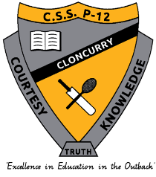**Cloncurry State School P-12**

**Minor/Major Behaviour Definitions**

|  |  |  |  |  |  |
| --- | --- | --- | --- | --- | --- |
| Behaviour Category | Definition | Minor Behaviour | | Major Behaviour | |
| Examples | Logical Consequence | Examples | Logical Consequences |
| Academic Misconduct | Student inappropriately and falsely demonstrates their learning. It includes cheating, collusion, contract cheating, copying work, disclosing/receiving assessment information, fabricating, impersonation, examination misconduct, plagiarism. | * Copying information directly from a source. * Non submission or incomplete submission of assessment, including drafts and other assessment checkpoints. | * Resubmission of assessment. * Zero or N result for assessment. * Contact with parent/carer. | * Copying or submitting other students work. * Cheating in an exam * Distributing copy of exam or assessment response to other students. * Repeated pattern of non-submission or incomplete submission of assessment, including drafts and other assessment checkpoints. | * Meeting between HOD/DP, Parent and student. * Internal suspension. |
| Abusive Language | Student delivers verbal messages that include swearing, name calling, or use of words in an inappropriate way. | * Use of inappropriate language in conversation that is non-threatening and indirect. * Mutual use of directed abusive language between students. | * Verbal correction. * Contact with parent/carer. * Loss of privileges. * Restorative practices. | * Use of abusive language directed towards a member of staff or in response to their instructions. * Use of abusive language that is threatening and directed towards staff and/or students. i.e. racial slurs; sexually explicit communication/conduct; derogatory swearing. | * Restorative practices. * Loss of privileges. * Short suspension (1-10 days). * Long suspension (11-20 days) for repeated incidents. |
| Bomb Threat/False Alarm | Student delivers a message of possible explosive materials being on campus, near campus, and/or pending explosion. |  |  | * Triggering an emergency evacuation based on a falsehood. | * Long suspension (20 day suspension pending exclusion). |
| Bullying | Student engages in deliberate verbal, physical and/or social behaviour intended to cause ongoing physical social and/or psychological harm. Bullying can occur in person, or online (cyberbullying). Bullying may be obvious or hidden. | * Isolated incidents of low-level name calling. * New incidents of low level name calling over a short period. | * Contact with parents. * Restorative practices. * Loss of privileges (detention). | * Persistent and deliberate verbal, physical and or/social behaviour in person or online that is malicious in its nature, including bystander behaviour. | * Restorative practices. * Loss of privileges. * Short suspension (1-10 days). * Long suspension (11-20 days) for repeated incidents. |
| Defiance | Student refuses to follow directions given by school staff. | * Isolated incidents of refusing to participate in an activity or event as instructed. * Refusal to follow through with a logical consequence. | * Lunch detention to complete missed activity or event. * Contact home. * Behaviour monitoring card. * Referral to Reflection Room. * Restorative conversation. | * Persistent pattern of refusing to participate in an activity or event as instructed. * Refusing to follow staff instructions to hand in phone when in breach of school mobile phone policy. * Refusing to follow instructions from the Deputy Principal or Principal. * Repeated refusal to follow through with a logical consequence. | * Individual Behaviour Support Plan. * Restorative practices. * Internal suspension. * Short suspension (1-10 days). * Long suspension (11-20 days) for repeated incidents. |
| Disrespect | Student intentionally delivers socially rude or dismissive messages to adults or students. | * Isolated incident of students being socially rude or dismissive to staff or students, that does not involve abusive language. | * Contact home. * Loss of privilege. * Restorative practices. | * Persistent incidents of student being social rude or dismissive to staff or student, that does not involve abusive language. | * Restorative practices. * Internal suspension. * Short suspension (1-10 days). |
| Disruption | Student engages in behaviour causing an interruption in a class or school activity or event. Disruption includes sustained loud talk, yelling, or screaming; noise with materials; and/or sustained out-of-seat behaviour. | * Loud talking. * Yelling/screaming. * Unnecessary noise with/without materials. * Out of seat behaviour. | * Use of ESCMs. * Referral to Reflection Room. * Contact home. * Restorative practices. | * Deliberate and persistent loud talk, yelling/screaming, noise with materials or out of seat behaviour despite previous supports. | * Restorative practices. * Behaviour Monitoring Card. * Individual Behaviour Support Plan. * Internal suspension. * Short suspension (1-10 days). * Long suspension (11-20 days) for repeated incidents. |
| Dress Code | Student wears clothing that is not within the dress code guidelines defined by the school. | * Winter clothing during hot summer days. * Inappropriate clothing i.e. tights/bike pants. * Clothing with inappropriate wording/language. * Inappropriate foot wear. | * Withdrawal from classes until infringement is rectified. * Referral to CEC to ensure student has appropriate uniform. * Contact home. |  |  |
| Falsifying Documents | Student intentionally creates, changes or modifies a document with the intention of misleading. It includes signing a person’s name without that person’s permission. | * Forging parent signature. | * Contact with parent/guardian. * Loss of privileges. |  |  |
| Fighting | Student is involved in mutual participation in an incident involving physical violence. | * Pushing or grabbing as a result of a disagreement. No injury or harm occurred to either party. | * Restorative practices. * Loss of privileges. * Contact home. | * Premediated physical fight involving two or more individuals. * Physically striking another person resulting in injury or harm. | * Restorative practices. * Internal suspension. * Short suspension (1-10 days) * Long suspension (11-20 days) for repeated incidents |
| Harassment | Student engages in the delivery of harmful messages in any format related to gender identity; ethnicity; sex; race; religion; disability; physical features or other identity characteristics. | * Isolated incident of the delivery of harmful messages in any format related to gender identity, ethnicity, sex, race, religion, disability physical feathers or other identity characteristics. | * Formal apology. * Restorative practices. * Contact home. * Loss of privileges. | * Sustained delivery of harmful messages in any format related to gender identity, ethnicity, sex, race, religion, disability, physical features or other identity characteristics | * Restorative practices * Internal suspension. * Short suspension (1-10 days) * Long suspension (11-20 days) * 20 suspension pending exclusion depending on the nature of the messages. * Possible reporting to QPS |
| Physical Aggression | Student intentionally engages in actions involving physical contact with others where injury may occur (e.g., hitting, slapping, punching, hitting with an object, kicking, hair pulling, scratching, etc.). This includes premeditated acts or incitement of others to undertake physical aggression. Physical aggression may be directed towards peers, adults, visitors or animals; or flora or fauna. | * Physical aggression to flora or fauna. * Play which escalates to physical aggression without injury * Poking, prodding, pushing or pinching that does not cause harm. | * Contact home. * Loss of privilege * Restorative practices * Social ban | * Student intentionally engages in actions involving physical contact with others where injury may occur. * Hitting, slapping, punching, hitting with and object, kicking, hair pulling, scratching, spiting * This many include premeditated acts. * Physical aggression may be directed towards peers, adults, visitors or animals. * Assisted assault. | * Restorative practices. * Internal suspension. * Short suspension (1-10 days). * Long suspension (11-20 days). * 20 suspension pending exclusion depending on the nature of the incident. |
| Property misuse causing risk to others | Student engages in misuse of property which may cause a risk of injury or ill-health to others. Behaviour involving throwing objects or using objects in an unsafe manner causing injury. | * Property misuse that does not cause injury, but is unsafe. Eg. throwing objects around the classroom. | * Loss of privileges * Restorative practices | * Property misuse that causes injury to others, intentional or un-intentional. Eg. Deliberately kicking a ball that strikes another student causing harm. | * Loss of privilege. * Contact home. * Internal suspension. * Short suspension (1-10 days). |
| Substance misconduct involving tobacco and other legal substances | Student is in possession of, has supplied or is using tobacco, alcohol, other prohibited substances or implements (including vapes). |  |  | * Students witnessed smoking or vaping on school grounds. | * Parent/Carer contact. * Referral to drugs and alcohol councillor. * Internal suspension. * Short suspension (1-10 days). * Referral to QPS. |
| Substance misconduct involving illegal substances | Student is in possession of, has supplied or is using illegal drugs/substances/imitations or implements. |  |  | * Possession of illegal drugs/substances. * Possession of illegal drug/substance paraphernalia. * Selling of illegal drugs/substances. | * Parent/Carer contact. * Referral to drugs and alcohol councillor. * Long suspension (11-20 days). * 20-day suspension pending exclusion. * Reporting to QPS. |
| Technology violation | Student engages in inappropriate (as defined by school) use of mobile phone, drone, smartwatch, camera, computer or other communication device. This includes fraudulent or illegal activity such as attempting to hack, implementing DoS attacks, use of key loggers, impersonating staff or other students. | * Use of mobile phone, headphones or smartwatch during the school day. * Off task behaviour on computer or ipad during class time (playing games, instant messaging) | * Parent contact. * Phone handed into the office. * Loss of privilege. * Lunch time detention. | * Accessing explicit or inappropriate websites on personal technology while at school. * Filming and sharing a fight between students. | * Parent contact. * Loss of privilege. * Referral to GO/external councillor. * Internal suspension. * Short suspension (1-10 days). |
| Theft | Student is involved by being in possession of, having passed on, or being responsible for removing school or someone else's property. | * Student takes classroom resources. | * Parent/Guardian contact * Restorative practices * Loss of privilege. | * Student deliberately takes money or personal items from another person (staff or student) | * Parent/Guardian contact * Restorative practices * Restitution * Loss of privilege. |
| Truancy | Student is present at school, but is absent for one or more scheduled classes without permission or appropriate reason. | * Late to class unexplained * Truancy – not being present in class but present at school. | * Lunch detention to complete missed activity or event. * Loss of privilege. * Contact home. | * Repeated incidents of late to class. * Truancy – Leaving the school grounds without permission or without following the correct sign out processes. | * Loss of privilege. * Contact home. * Admin Leader follow up. * Restorative practices. |
| Use/possession of combustibles | Student is/was in possession of substances/objects readily capable of causing bodily harm and/or property damage (e.g. matches, lighters, firecrackers, petrol, lighter fluid, aerosols). | * Possession of matches, lighters. * Inappropriate use of aerosols. | * Confiscation * Parent/Carer contact. | * Deliberating lighting a fire on school grounds. | * Contact home. * Internal suspension. * Short suspension (1-10 days). * Long suspension (11 – 20 days) * 20 day suspension pending exclusion |
| Use/possession of weapons | Student is in possession of knives and guns (real or look alike), or other objects readily capable of causing bodily harm. |  |  | * Purposefully bringing a knife to school. * Threatening staff/students with a weapon. | * Long suspension (11 – 20 days). * 20 day suspension pending exclusion. |
| Other – charge-related suspension | Principal is reasonably satisfied that the student has been charged with a serious offence; or charged with an offence other than a serious offence, and that the nature of the offence precludes the student’s attendance on the basis that they pose an unacceptable risk to other students or staff. |  |  |  | * Charge related suspension pending the outcome of the charges laid. * Possible exclusion. |

School Disciplinary Absences

A School Disciplinary Absence (SDA) is an enforced period of absence from attending a Queensland state school, applied by the Principal as a consequence to address poor student behaviour. There are four types of SDA:

* short suspension (1 to ten school days);
* long suspension (11 to 20 school days);
* charge-related suspension;
* exclusion (period of not more than one year or permanently).

At Cloncurry State School P-12, the use of any SDA is considered a very serious decision. It is typically only used by the Principal when it is a major or serious matter and other options have been exhausted or the student’s behaviour is so dangerous that continued attendance at the school is considered a risk to the safety or wellbeing of the school community.

Parents and students may appeal a long suspension, charge-related suspension or exclusion decision. A review will be conducted by the Director-General or their delegate, and a decision made within 40 school days to confirm, amend/vary or set aside the original SDA decision by the Principal.

The appeal process is a thorough review of all documentation associated with the SDA decision and provides an opportunity for both the school and the family to present their case in the matter. Time is afforded for collection, dissemination and response to the materials by both the school and the family. It is important that the purpose of the appeal is understood so that expectations are clear, and appropriate supports are in place to ensure students can continue to access their education while completing their SDA.

**Re-entry following suspension**

Students who are suspended from Cloncurry State School P-12 will be required to attend a re-entry meeting on the day of their scheduled return to school. The main purpose of this meeting is to welcome the student, with their parents/carers if possible, back to the school. The aim of the re-entry meeting is for school staff to set the student up for future success and strengthen home-school communication.

The re-entry meeting is offered as a support for the student to assist in their successful re-entry engagement in school following suspension.

**Arrangements**

The invitation to attend the re-entry meeting will be communicated via telephone and in writing, usually via email. Re-entry meetings are kept small with only the relevant stakeholders attending with the student and their parent/carer/s.

A record of the meeting is saved in OneSchool, under the Contact tab, including any notes or discussions occurring during the meeting.

**Reasonable Adjustments**

In planning the re-entry meeting, school staff will consider reasonable adjustments needed to support the attendance and engagement of the student. This includes selecting an appropriate and accessible meeting space, organising translation or interpretation services or supports (eg. AUSLAN), provision of written and/or pictorial information and other relevant accommodations. The inclusion of support staff, such as Guidance Officers or Community Education Counsellors, may also offer important advice to ensure successful outcome of the re-entry meeting.

|  |
| --- |
| School Policies |
|  |

Cloncurry State School P-12 has tailored school discipline policies designed to ensure students, staff and visitors work cooperatively to create and maintain a supportive and safe learning environment. Please ensure that you familiarise yourself with the responsibilities for students, staff and visitors outlined in the following policies:

* Temporary removal of student property;
* Use of mobile phones and other devices by students;
* Preventing and responding to bullying;
* Appropriate use of social media;
* Use of restrictive practices;
* Management of critical incidents.

**Temporary removal of student property**

The removal of any property in a student’s possession may be necessary to promote the caring, safe and supportive learning environment of the school, to maintain and foster mutual respect between all state school staff, students and visitors. The *Temporary removal of student property by school staff procedure* outlines the processes, conditions and responsibilities for state school principals and school staff when temporarily removing student property.

In determining what constitutes a reasonable time to retain student property, the Principal or state school staff will consider:

* the condition, nature or value of the property;
* the circumstances in which the property was removed;
* the safety of the student from whom the property was removed, other students or staff members;
* good management, administration and control of the school.

The Principal or state school staff determine when the temporarily removed student property can be returned, unless the property has been handed to the Queensland Police Service.

The following items are explicitly prohibited at Cloncurry State School P-12 and will be removed if found in a student’s possession:

* illegal items or weapons (eg. Guns, knives*, slingshots);
* imitation guns or weapons;
* potentially dangerous items (eg. blades, rope);
* drugs**;
* drug paraphernalia;
* alcohol;
* aerosol deodorants or cans (including spray paint);
* explosives (eg. Fireworks, flares, sparklers);
* flammable solids or liquids (eg. Fire starters, lighters);
* poisons (eg. Weed killer, insecticides);
* inappropriate or offensive material (eg. Racist literature, pornography, extremist propaganda);
* cigarettes and vapes;
* energy drinks.

*No knives of any type are allowed at school, including pocket knives, flick knives, ballistic knives, sheath knives, push daggers, trench knives, butterfly knives, star knives, butter knives, fruit knives, or craft knives, or any item that can be used as a weapon, for example a chisel. Knives needed for school activities will be provided by the school, and the use of them will be supervised by school staff. In circumstances where students are required to have their own knives or sharp tools for particular subjects or vocational courses, the school will provide information about the procedures for carrying and storing these items at school.

**The administration of medication to students by school staff is only considered when a prescribing health practitioner has determined that it is necessary or when there is no other alternative in relation to the treatment of a specific health need. Schools require medical authorisation to administer any medication to students (including over-the-counter medications such as paracetamol or alternative medicines).

**Responsibilities**

**Principal**

* Ensures state school staff are aware of the responsibilities outlined in this procedure that must be followed when temporarily removing student property, including that:
  + consent is not required to search school property such as lockers, desks or laptops that are supplied to the student through the school.
  + consent is required from the student or parent to open, examine or otherwise deal with the temporarily removed student property. For example, without the consent of

the student or parent, principals or state school staff who temporarily remove a mobile phone from a student are not authorised to unlock the phone or to read, copy or delete messages stored on the phone.

* + where there is suspicion that the student has a dangerous item (for example, a knife) in their school bag, principals or state school staff should seize the bag immediately and remove the student’s access prior to seeking search consent or call the police. Under no circumstances should the student be permitted to go into the bag themselves.
  + under normal circumstances, principals and state school staff members are not permitted to search student property (eg. A student’s school bag) unless they have the consent of the student or their parent.
  + under emergency circumstances only, such as a need to access an EpiPen for an anaphylactic emergency, principals or state school staff may need to search a student’s property without he student’s consent or the consent of the student’s parents.
  + principals or state school staff do not have the authority to search the person of a student, if a search is considered necessary the police should be called to make such a determination.
* Ensures parents and students are:
  + informed of the procedure which enables state school staff to temporarily remove student property and the expectations in relation to property students may bring to school.
  + aware of the right to refuse permission for state school staff to search student property, and that police may be called if consent is not provided.
  + provide with clear communication to inform what student property can be temporarily removed and the expectations in relation to property students may bring to school.
* Ensures information about this procedure is clearly detailed in the Student Code of Conduct, including:
  + that state school staff may in certain circumstances remove student property with the consent of parents or students.
  + the limits on state school staff accessing information from temporarily removed student property, such as mobile phones.
  + examples of property that may be temporarily removed, such as bags, mobile phones, jewellery or prohibited items such as knives.
  + examples of the amount of time certain property may be temporarily removed.
  + that student property may be seized by police.

**State school staff**

* Follow appropriate processes outlined in the Student Code of Conduct regarding:
  + temporary removal of student property;
  + access to information on temporarily removed student property;
  + return of temporarily removed student property;
  + circumstances where temporarily removed student property need not be made available for collection;
  + deciding a reasonable time to make temporarily removed student property available for collection.

**Students**

* Must not bring property onto school grounds or other settings used by the school (e.g. camp, or sport venues) that:
  + is prohibited according to the school’s Student Code of Conduct;
  + is illegal (e.g. drugs such as cannabis, ecstasy or amphetamines);
  + puts the safety or wellbeing of others at risk (e.g. knife, firearm, handcuffs or replica firearms);
  + does not preserve a caring, safe, supportive or productive learning environment (e.g. cigarettes or vapes);
  + does not maintain and foster mutual respect (e.g. printed materials with offensive language or extremist propaganda).
* Must collect their property as soon as possible when advised by the principal or state school staff it is available for collection.

**Parents**

* Ensure their children do not bring property onto school grounds or other settings used by the school that:
  + is prohibited according to the school’s Student Code of Conduct;
  + is illegal (e.g. drugs such as cannabis, ecstasy or amphetamines);
  + puts the safety or wellbeing of others at risk (e.g. knife, firearm, handcuffs or replica firearms);
  + does not preserve a caring, safe, supportive or productive learning environment (e.g. cigarettes or vapes);
  + does not maintain and foster mutual respect (e.g. printed materials with offensive language or extremist propaganda).
* Collect temporarily removed student property as soon as possible after they have been notified by the principal or state school staff that the property is available for collection.

**Use of mobile phones and other devices by students**

**Mobile Phone Policy**

Cloncurry State School P-12 supports the announcement by Queensland Education Minister Grace Grace that mobile phones and certain wearable electronic devices like smartwatches will be banned at all Queensland state schools during school hours, including break times, from Term 1, 2024. Mobile phone use in schools can impact student learning and wellbeing. Restricting mobile phone use at school aims to increase focus in classrooms, remove distractions and promote positive social interaction, while reducing the protentional for online bullying. Cloncurry State School P-12 has strong teaching and learning practices to support students in the classroom using various forms of appropriate technology, which maximises the benefits and minimises the risks of digital environments and prepare students for life beyond school.

Cloncurry State School P-12 has elected to use the following approach to support the management of the mobile phone policy:

* All mobile phones will be switched off and stored in lockers, located in the school library, for the full school day, including morning tea and lunch. This is an approved Education Queensland option and will limit unnecessary distractions.
* It will be the student’s responsibility to lock their phone in their assigned locker at the beginning of the school day and to collect their phone at the end of the school day.
* A set of mobile phone lockers will be located in the school administration office for students to use if they arrive to school late.
* Any student who is seen using their phone during the school day will be directed to hand their phone into to the school administration office. A parent/carer will be notified to collect the phone from the school office.
* Repeated incidents of using a mobile phone during the school day may lead to disciplinary consequences such as loss of privilege, detention or suspension.

**Responsibilities**

**School**

* Provide individual mobile phone lockers for students to access before and after school.
* Clearly communicate mobile phone policy to students, parents/carers and wider school community.
* Consistently follow the mobile phone policy and direct all students using a mobile phone during the school day to the office to hand in for collection by a parent/carer.
* Refer any students refusing to follow mobile phone policy to the school leadership team to appropriately respond and follow up.

**\***Cloncurry State School P-12 does not take responsibility for damage or loss of mobile phones if students choose to bring their mobile device to school.

**Students**

* Adhere to the Cloncurry State School P-12 mobile phone policy.
* If brining a mobile phone to school, using the assigned mobile phone locker to store phone during the school day, including break times.
* Follow all staff directives to hand mobile phone into the school office if observed using their phone during the school day.

**Parents/Carers**

* Encourage students to keep their mobile phones at home.
* If child is required to bring their phone to school, encourage them to follow the school mobile phone policy.
* Collect phone from the school administration office if notified that their child was using their phone during the school day and was required to hand it in.

**Appropriate use of Information and Communication Technology (ICT)**

At all times students, while using ICT facilities and devises supplied by the school, will be required to act in line with the requirements of the Cloncurry State School P-12 Student Code of Conduct. In addition, students and the parents should:

* Understand the responsibility and behaviour requirements (as outlined by the school) that come with accessing the departments ICT network facilities.
* Ensure they have the skills to report and discontinue access to harmful information if presented via the internet or email.
* Be aware that:
  + access to ICT facilities and devices provides valuable learning experiences for students and supports the school’s teaching and learning programs;
  + the school is not responsible for safe guarding information stored by students on departmentally-owned student computers or mobile devices (iPad);
  + schools may remotely access departmentally-owned student computers or mobile devices for management purposes;
  + students who use a school’s ICT facilities and devices in a manner that is not appropriate may be subject to disciplinary action by the school, which could include restricting network access;
  + despite internal departmental controls to manage content on the internet, illegal dangerous or offensive information may be accessed or accidentally displayed;
  + teachers will always exercise their duty of care, but avoiding or reducing access to harmful information also requires responsible use by the student.

When enrolling at Cloncurry State School P-12, students agree to adhere to the following expectations regarding the appropriate use of ICT facilities:

* use ICT facilities for education purposes that relate to the subjects being taught;
* not look for anything illegal, dangerous or inappropriate;
* agree to clear any offensive pictures or information from their screen;
* not reveal home addresses or phone numbers (personal or another individual’s) and understand that it is illegal to do so;
* will not use the internet or email for personal use or to annoy or offend anyone;
* understand that the Principal has the ability to remove student access to the school internet and/or email either temporarily or permanently, if they decide a student has broken any rules involving appropriate ICT use.

Cloncurry State School P-12 is committed to ensuring all students have access to appropriate technology to assist their learning. Students across Year 3 to 12 have one-to-one devices while students from Prep to Year 2 have access to age appropriate technology. Cloncurry State School P-12 provides students from Year 3 to Year 9 with an iPad that they can access during each lesson while at school. Students in Year 10, 11 and 12 will be able to participate in the school laptop program to support the rigorous learning demands experienced in the senior phase of learning. It is important that students and parent/carer/s are aware of the information below pertaining to student access to technology:

* Students in Year 10, 11 and 12 can take their laptops home on payment of their student levies (payment plans are available).
* Students across years 3 to 9 who have access to and iPad are not permitted to take the iPad home.
* Any wilful damage that occurs to a laptop or iPad may result in financial remuneration incurred by the student/family.

**Preventing and responding to bullying**

Cloncurry State School P-12 uses the *Australian Student Wellbeing Framework* to promote positive relationships and the wellbeing of all students, staff and visitors at the school.

Our staff know student learning is optimised when they feel connected to others and experience safe and trusting relationships. Students who feel secure are more likely to be active participants in their learning and to achieve better physical, emotional, social and educational outcomes. Teachers who feel valued and supported are more likely to engage positively with students and build stronger connections within the school community. Parents who are positively engaged with their child’s education lead to improved student self-esteem, attendance and behaviour at school. Enhancing the wellbeing of students and their educators delivers overall long-term social, health and economic benefits to the Australian community.

**Australian Student Wellbeing Framework**

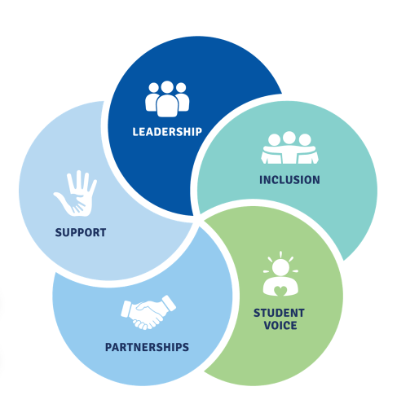

1. **Leadership** – Principals and school leaders play an active role in building a positive learning environment where the whole school community feels included, connected, safe and respected.
2. **Inclusion** – All members of the school community are active participants in building a welcoming school culture that values diversity, and fosters positive, respectful relationships.
3. **Student voice** – Students are active participants in their own learning and wellbeing, feel connected and use their social and emotional skills to be respectful and resilient.
4. **Partnerships** – Families and communities collaborate as partners with the school to support student learning, safety and wellbeing.
5. **Support** – School staff, students and families share and cultivate an understanding of wellbeing and positive behaviour and how this supports effective.
6. teaching and learning.

**Bullying**

The agreed national definition for Australian schools describes bullying as:

* ongoing and deliberate misuse of power in relationships through repeated verbal, physical and/or social behaviour that intends to cause physical, social and/or psychological harm;
* involving an individual or a group misusing their power, or perceived power, over one or more persons who feel unable to stop it from happening;
* happening in person or online, via various digital platforms and devices and it can be obvious (overt) or hidden (covert);
* behaviour that is repeated, or has the potential to be repeated, over time (for example, through sharing of digital records);
* having immediate, medium and long-term effects on those involved, including bystanders.

**Single incidents and conflict or fights between equals, whether in person or online, are not defined as bullying.** Behaviours that do not constitute bullying include:

* mutual arguments and disagreements (where there is no power imbalance);
* not liking someone or a single act of social rejection;
* one-off acts of meanness or spite;
* isolated incidents of aggression, intimidation or violence.

However, these conflicts are still considered serious and need to be addressed and resolved. At Cloncurry State School P-12 our staff will work to quickly respond to any matters raised of this nature in collaboration with students and parents.

The following flowchart explains the actions Cloncurry State School P-12 teachers will take when they receive a report about student bullying, including bullying which may have occurred online or outside of the school setting. Please note that the indicative timeframes will vary depending on the professional judgement of teachers who receive the bullying complaint and their assessment of immediate risk to student/s.

**Bullying response flowchart for teachers**

Please note these timelines may be adjusted depending on the unique circumstances and risk associated with each situation. This is at the professional judgment of the staff involved. Timeframes should be clearly discussed and agreed with student and family.

**Key contacts for students and parents to report bullying:**

**Prep to Year 6** – Class teacher

**Year 7 to Year 12** – Classroom teacher or Head of Department – Senior Schooling

**Guidance Officer** – 07 4742 8333

* Provide a safe, quiet space to talk
* Reassure the student that you will listen to them
* Let them share their experience and feelings without interruption
* If you hold immediate concerns for the student's safety, let the student know how you will address these. Immediate in this circumstance is where the staff member believes the student is likely to experience harm (from others or self) within the next 24 hours
* Continue to check in with student on regular basis until concerns have been mitigated
* Record notes of follow-up meetings in OneSchool
* Refer matter to specialist staff within 48 hours if problems escalate
* Look for opportunities to improve school wellbeing for all students
* Evaluate the information to determine if bullying has occurred or if another disciplinary matter is at issue
* Make a time to meet with the student to discuss next steps
* Ask the student what they believe will help address the situation
* Provide the student and parent with information about student support network
* Agree to a plan of action and timeline for the student, parent and yourself
* Ask the student for examples they have of the alleged bullying (e.g. hand written notes or screenshots)
* Write a record of your communication with the student
* Check back with the student to ensure you have the facts correct
* Enter the record in OneSchool
* Notify parent/s that the issue of concern is being investigated
* Gather additional information from other students, staff or family
* Review any previous reports or records for students involved
* Make sure you can answer who, what, where, when and how
* Clarify information with student and check on their wellbeing
* Document the plan of action in OneSchool
* Complete all actions agreed with student and parent within agreed timeframes
* Monitor the student and check in regularly on their wellbeing
* Seek assistance from student support network if needed
* Meet with the student to review situation
* Discuss what has changed, improved or worsened
* Explore other options for strengthening student wellbeing or safety
* Report back to parent
* Record outcomes in OneSchool

**Stymie**

All members of the school and wider community have the option to anonymously report concerns that they have about a student or students at our school using the online platform Stymie. The web address is: <https://stymie.com.au/>

Stymie provides online reporting for schools. Encrypted, anonymous notifications are delivered within seconds to authorised recipients, who respond according to their wellbeing framework. The notification provides the option to include screenshots or images that validate the notification.

Suicide ideation, discrimination, anxiety, depression, bullying, self-harm, physical fights, sexual assault, family violence and illegal activity are reported using Stymie. Students can also request to see a counsellor via the platform, by selecting this option on the online form.

The purpose of Stymie is to support psychological safety by empowering young people with the self-belief that they can #saysomething on behalf of themselves or as a bystander for someone else.

**Reporting Process**

1. Go to the website: <https://stymie.com.au/>
2. Click “I understand” to agree that you will use Stymie appropriately. This notification is there to remind users that they are breaking the law if they use Stymie to tell lies, menace, harass or be offensive.
3. Fill out the boxes provided in the form with as much detail as possible:

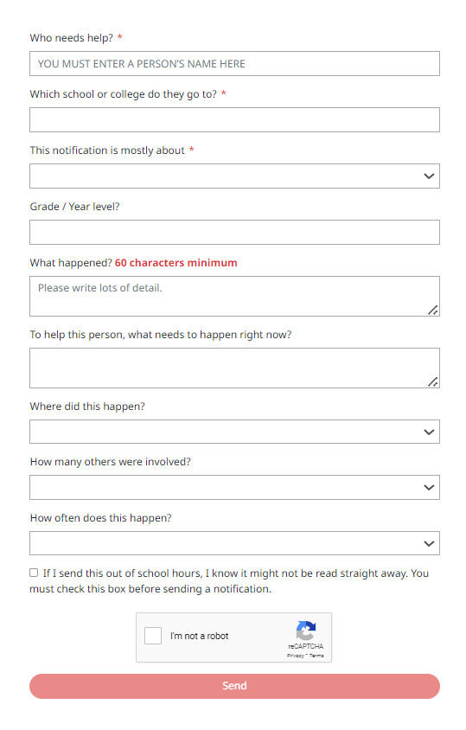

* Students are not to use this platform to tell lies about staff members or students to get them into trouble.
* Put in at least one name, so we can speak to those affected by the issue. Full name is preferred.
* Fill in as much information as possible about what happened, where, when etc, to make it possible for the staff member/s following up to do this efficiently.
* Please report as soon as possible after you are aware of an issue or have a concern. It will allow the school a chance to intervene before an issue gets worse or further harm occurs.

**Cyberbullying**

Cyberbullying is treated at Cloncurry State School P-12 with the same level of seriousness as in-person bullying. The major difference with cyberbullying however, is that unlike in-person bullying, cyberbullying follows students into their community, their homes and their bedrooms, giving them no opportunity to escape the harassment or abuse during the evening, weekends or holidays.

In the first instance, students or parents who wish to make a report about cyberbullying should approach the regular class teacher. The guidance officer can also be approached directly by students, parents or staff for assistance in preventing and responding to cyberbullying.

It is important for students, parents and staff to know that state school principals have the authority to take disciplinary action to address student behaviours that occur outside of school hours or school grounds. This includes cyberbullying. Parents and students how have concerns about cyberbullying incidents occurring during school holidays should immediately seek assistance through the Office of the e-Safety Commissioner or the Queensland Police Service.

Students enrolled at Cloncurry State School P-12 may face in-school disciplinary action, such as detention or removing of privileges, or more serious consequences such as suspension or exclusion from school for engaging in behaviour that adversely affects, or is likely to adversely affect, other students or the good order and management of the school. This includes behaviour such as cyberbullying which occurs outside of school hours or settings, for example on the weekend or during school holidays. It also applies to inappropriate online behaviour of enrolled students that is directed towards other community members or students from other school sites.

Parents or other stakeholders who engage in inappropriate online behaviour towards students, staff or other parents may be referred to the Office of the e-Safety Commissioner and/or the Queensland Police Service. State school staff will be referred for investigation to the Integrity and Employee Relations team in the Department of Education. Any questions or concerns about the school process for managing or responding to cyberbullying should be directed to the Guidance Officer.

Cloncurry State School P-12 subscribes to Stymie reporting platform, which provides students with the opportunity to anonymously report any incidents of bullying or cyberbullying. Students access Stymie reporting through the website, [www.stymie.com.au](http://www.stymie.com.au).

**Cyberbullying response flowchart for school staff**

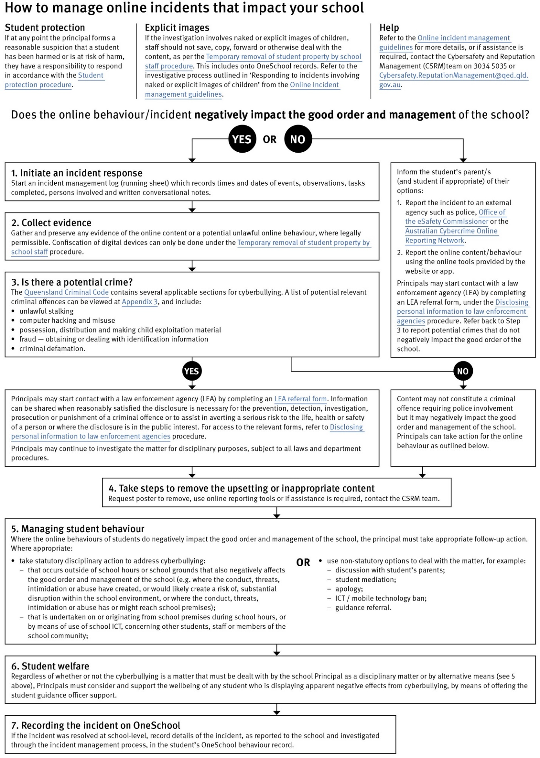

**Appropriate use of social media**

The internet, mobile phones and social media provide opportunities for students to network and socialise online. While these technologies provide positive platforms for sharing ideas, they also have the potential to cause pain and suffering to individuals, groups or even whole communities.

It’s important to remember that sometimes negative comments posted about the school community have a greater impact that expected. This guide offers some information about how to use social media in relation to comments or posts about the school community. Reputations of students, teachers, schools, principals and even parents can be permanently damaged – and in some cases, serious instances of inappropriate online behaviour are dealt with by police and the court system.

Being aware of a few simple strategies can help keep the use of social media positive and constructive:

* Before you post something online, ask yourself if the community or individual really need to know. Is it relevant, positive and helpful?
* Remember that what you post online is a direct reflection of who you are. People will potentially form lasting opinions of you based on what you post online.
* Be a good role model. If things get heated online, consider logging out and taking a few moments to relax and think. Hasty, emotive responses could inflame situations unnecessarily.
* Be mindful when commenting, try to keep general and avoid posting anything that could identify individuals.
* Taking a few moments to think about the content you are about to post could save upset, embarrassment and possible legal action.

**Is it appropriate to comment or post about schools, staff or students?**

Parental and community feedback is important for schools and the department. If you have a compliment, complaint or enquiry about an issue at school, the best approach is to speak directly to the school about the matter, rather than discussing it in a public forum.

While many schools use social media to update parents of school notices, the department prefers that parents contact schools directly with a compliment, complaint or enquiry due to privacy considerations. Imagine in you doctor, accountant or banking institution tried to contact you to discuss matters via Facebook.

If you have raised an issue with a school or know that another person has, consider refraining from discussing those details on social media, particularly the names of anyone involved.

Keep comments calm and polite, just as you would over the telephone oy by email. If you encounter negative or derogatory content online which involves the school, hinders a child’s learning and/or affects the school community at large, contact the school principal.

**Possible civil or criminal ramifications of online commentary**

A serious instance of inappropriate online behaviour may constitute a criminal offence and become a police matter. For example, online content may substantiate the offence of ‘using a carriage service to menace, harass or cause offence’ (Criminal Code Act 1995 (Cth) s. 474. 17). School staff may contact their union or obtain personal legal advice if they feel that online content seriously impacts their reputation. Defamatory online content may give rise to litigation under the Defamation Act 2005 (Qld).

**What about other people’s privacy?**

If you upload photos of your children, be mindful of who might be in the background. You might be happy to share your child’s successes with your friends and family via social media, but some parents are not. If you are tagging or naming students, consider that other parents may not want their child’s name attached to images online.

**What if I encounter problem content?**

Taking the following steps may help resolve the issue in a constructive way:

* refrain from responding;
* take a screen capture or print a copy of the concerning online content;
* if you consider problem content to be explicit, pornographic or exploitative of minor, you should keep a record of the URL of the page containing that content but NOT print or share it. The URL can be provided to the school principal, or police as needed for escalation of serious concerns;
* block the offending user;
* report the content to the social media provider.

**Cybersafety and Reputation Management**

The Department of Education employs a dedicated team of experts to assist in maintaining the integrity of the department’s reputation with regards to cybersafety and reputation management issues, effectively leading the development and implementation of departmental cybersafety processes.

This team provides direct support for schools to respond to concerns of inappropriate online behaviour and misuse of information and communication technology.

The team provides a guide for parents with important information about cybersafety and cyberbullying, and suggestions about what you can do if you child is a target or responsible for inappropriate online behaviour.

The team has also developed a Cyberbullying and reputation management (Department employees only) resource to assist principals in incident management.

**Restrictive Practices**

In some very rare situations, where there is immediate risk of physical harm to the student or other people, and when all other alternative strategies have failed to reduce the risk, it may be necessary for staff to use restrictive practices.

The use of restrictive practices will always be as a last resort, when there is no other available option for reducing immediate risk to the student, staff or other people. Restrictive practices are not used for punishment or as a disciplinary measure.

The department’s **Restrictive practices procedure** is written with consideration for the protection of everyone’s human rights, health, safety and welfare. There are six fundamental principles:

1. Regard to the human rights of those students;
2. Safeguards students, staff and others from harm;
3. Ensures transparency and accountability;
4. Places importance on communication and consultation with parents and carers;
5. Maximises the opportunity for positive outcomes, and;
6. Aims to reduce or eliminate the use of restrictive practices.

Very rarely restrictive practices will be planned and staff will employ, when necessary, pre-arranged strategies and methods (of physical restraint/ mechanical restraint/ clinical holding) which are based upon behaviour risk assessment or clinical health need and are recorded in advance. The use of planned strategies will only be where there is foreseeable immediate risk consistent with the **Restrictive practices procedure**.

Seclusion will not be used as a planned response and will only be used in serious circumstances for managing an unforeseeable situation in an emergency. It will be used for the shortest time possible and in a safe area that presents no additional foreseeable risk to the student. In such emergencies, a staff member will observe the student at all times and seclusion will cease as soon as possible.

Following the use of any restrictive practice, a focused review will help staff to understand how they responded to the risk in any incident that involved the use of a restrictive practice. Staff will consider whether there are other options for managing a similar situation in the future. This strategy works well for reducing the use of restrictive practices.

All incidents of restrictive practices will be recorded and reported in line with departmental procedures.

**Critical Incidents**

It is important that all school staff have a consistent understanding of how to respond in emergencies that seriously endanger students or others. This consistency ensures that appropriate actions are taken to ensure that both students and staff are kept safe.

A critical incident is defined as an occurrence that is sudden, urgent, and usually unexpected, or an occasion requiring immediate action (e.g. in the community, on the road). The aim in these situations is to bring the behaviour of the student under rapid and safe control. It is not a time to try and punish or discipline the student. It is a crisis management period only.

Staff should follow the documented plan for any student involved in regular critical incidents, which should be saved and available for staff to review in OneSchool.

For unexpected critical incidents, staff should use basic defusing techniques:

1. Avoid escalating the problem behaviour: avoid shouting, cornering the student, moving into the student’s space, touching or grabbing the student, sudden responses, sarcasm, becoming defensive, communicating anger and frustration through body language.
2. Maintain calmness, respect and detachment: model the behaviour you want students to adopt, stay calm and controlled, use a serious measured tone, choose your language carefully, avoid humiliating the student, be matter of fact and avoid responding emotionally.
3. Approach the student in a non-threatening manner: move slowly and deliberately toward the problem situation, speak privately to the student/s where possible, speak calmly and respectfully, minimise body language, keep a reasonable distance, establish eye level position, be brief, stay with the agenda, acknowledge cooperation, withdraw if the situation escalates.
4. Follow through: if the student starts displaying the appropriate behaviour briefly acknowledge their choice and re-direct other students’ attention towards their usual work/activity. If the student continues with the problematic behaviour, then remind them of the expected school behaviour and identify consequences of continued unacceptable behaviour.
5. Debrief: At an appropriate time when there is low risk of re-escalation, help the student to identify the sequence of events that led to the unacceptable behaviour, pinpoint decision moments during the sequence of events, evaluate decisions made and identify acceptable decision options for future situations.

|  |
| --- |
| Related Procedures and Guidelines |
|  |

These are related procedures or guidelines which school staff use to inform decisions and actions around matters associated with students’ wellbeing, behaviour and learning.

* Cancellation of enrolment.
* Complex case management.
* Customer complaints management policy and procedure.
* Disclosing personal information to law enforcement agencies.
* Enrolment in state primary, secondary and special schools.
* Hostile people on school premises, wilful disturbance and trespass.
* Inclusive education.
* Police and Child Safety Officer interviews and searches with students.
* Restrictive practices.
* Refusal to enrol – Risk to safety or wellbeing.
* Student discipline.
* Student dress code.
* Student protection.
* Supporting students’ mental health and wellbeing.
* Temporary removal of student property by school staff.
* Use of ICT systems.
* Using mobile devices.

|  |
| --- |
| Conclusion |
|  |

Cloncurry State School P-12 staff are committed to ensuring every student is supported to feel safe, welcome and valued in our school. There may, however, be occasions where parents need to raise a concern or make a complaint about an issue they feel is adversely affecting their child’s education.

All Queensland state schools are committed to ensuring that all complaints – whether they relate to a school staff member or a school’s operations – are dealt with in a fair and equitable manner. As a parent or carer, you can express dissatisfaction with the service or action of the Department of Education or its staff, including decisions made or actions taken in a school and/or by the local regional office.

As a complainant, it is your responsibility to:

* Give us a clear idea of the issue or concern and your desired solution.
* Provide all the relevant information when making the complaint.
* Understand that addressing a complaint can take time.
* Cooperate respectfully and understand that unreasonable, abusive or disrespectful conduct will not be tolerated.
* Let us know if something changes, including if help is no longer needed.

**The Department of Education may not proceed with your complaint if your conduct is unreasonable.**

In most instances, staff members are told of complaints made about them and offered the right of reply. A complainant also has the right to have a support person throughout the process.

The following three-step approach assists parents and school staff in reaching an outcome that is in the best interests of the student:

1. **Early resolution**: discuss your complaint with the school.

The best place to raise any concerns is at the point where the problem or issue arose. You can make an appointment at the school to discuss your complaint with your child’s teacher or the principal. You are also welcome to lodge your complaint in writing or over the phone. Complaints may be lodged by telephone, writing or email.

1. **Internal review**: contact the Regional Office.

If after taking the early resolution step, you are dissatisfied with the outcome of your complaint or how the complaint was handled, you can ask the local regional office to conduct a review. You need to submit a Request for internal review from within 28 days of receiving the complaint outcome.

1. **External review:** contact a review authority.

If you are dissatisfied after the internal review, you may wish to contact a review authority, such as the Queensland Ombudsman, and request an independent, external review. More information about external review options is available at [www.ombudsman.qld.gov.au](http://www.ombudsman.qld.gov.au).

Some matters need to be handled in a different way to school matters and will be referred to other areas in the department. These include:

* issues about harm, or risk of harm, to a student attending a state school, which must be managed in accordance with the Student Protection Procedure.
* complaints about corrupt conduct, public interest disclosures; or certain decisions made under legislation, which will be dealt with as outlined in the Excluded complaints factsheet.